
Project 3.1.1 Keystone Library Renovation

Introduction
When a business or industrial facility closes, even if the location is desirable, the building is sometimes left boarded up and abandoned, sometimes for years. Often these abandoned properties are not redeveloped because of the potential presence (whether contamination is actually present or not) of some type of contamination left behind by the previous property owners. These abandoned properties are referred to as brownfields.

Federal and state programs now encourage developers to clean up and redevelop these unused properties in an effort to revitalize unsightly areas. These incentives have provided funding sources for the assessment and remediation of brownfield sites that has allowed redevelopment and reuse of properties that were previously undesirable.

In this project you will plan the redevelopment of a (fictitious) existing industrial brownfield site in Noblesville, IN. The unit activities will guide you as you create a redevelopment plan to reuse the facility as a public library.

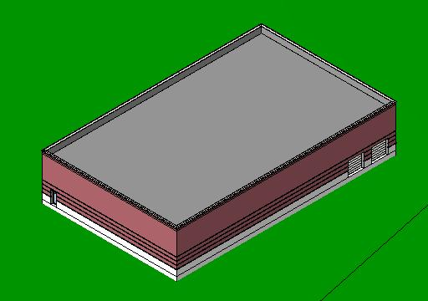
CAD model of existing industrial building

The City of Noblesville received a grant from the State of Indiana to assess the site for hazardous materials. The results of the investigation indicate that the property has insignificant levels of contamination and can be redeveloped without restriction on use. Of course, all applicable building codes and local regulations still apply to the development.

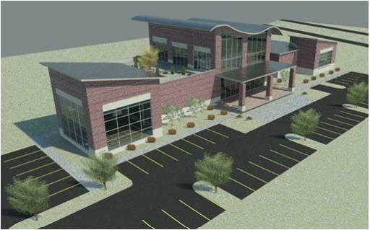
Example of completed Keystone Library Renovation

Equipment
- Engineering notebook
- Pencil
- 3D architectural software
- Internet access
- Keystone Library Renovation Preliminary Building (student version)
- Keystone Library Renovation Preliminary Site (student version)

Procedure
The existing building is approximately 76ft x 124ft and 20ft tall and is gutted. No interior walls or fixtures remain. You will utilize the existing structure to its fullest extent and add a partial second floor to the structure. The part of the existing roof that is not enclosed for the new second floor will be converted to a green roof that will be accessible to the public.

You will redesign the existing building to create a plan for renovating the structure to serve as a public library. As necessary, you will replace existing building components or add new components to provide a safe and efficient building with adequate utilities and services. You will also create a site design that will provide sufficient parking, desirable traffic flow, and appropriate grading and storm water management.

Constraints
- The design should follow all applicable building codes and local regulations.
- The existing structure will be fully utilized when possible.
- A new modern entryway and vestibule will be added to improve the aesthetics of the building, provide full accessibility, and include an exterior covered area with benches.
- An elevator must be provided for accessibility.
- First Floor plan must include areas designated for
- Entry and Circulation Desk area
- Children’s Help Desk
- Open area for stacks (shelves of books and media) and computer terminals
- Public restroom
- Head Librarian’s office
- Staff workroom/ kitchenette
- Staff restroom
- Two meeting rooms
- Noblesville History room
- Mechanical room
- Second Floor plan must include:
- Open floor area for stacks
- Public restroom

Deliverables
- Project Documentation Report to include the following.
- Title Page
- Table of Contents
- Project Description
- Describe the project, including existing conditions and proposed renovations.
- Code and Regulation Research Summary
- Document the codes that you used for the design of the library.
- Describe code and local ordinance regulations that impacted your design and document your research with section numbers.
- Engineering calculations to include the following.
- Composite Floor Load-Span table with selection highlighted (Activity 3.1.6)
- Roof Deck Design (Activity 3.2.2)
- Roof Joist Design (Activity 3.2.2)
- (Optional) Structural beam and girder calculations (Activity 3.2.7)
- Spread footing analysis (Activity 3.2.10)
- (Optional) Water supply pressure at meter and at second floor restroom fixture (Activity 3.3.2)
- (Optional) Wastewater discharge calculations (Activity 3.3.3)
- Heat Loss calculations (Activity 3.3.4)
- Storm water runoff and retention/detention pond size (Activity 3.4.5)
- Conclusion
- Answers to conclusion questions in narrative form.
- Set of Construction Drawings to include the following.
- C-1 Site Plan
- L-1 (Optional) Landscaping Plan
- A-1 First Floor Plan
- A-2 Second Floor and Green Roof Plan (show location of vegetation and walking surface)
- A-3 (Optional) Reflected Ceiling Plan of a Meeting Rooms and Head Librarians Office
- A-4 Roof Plan
- A-5 Two Elevations
- A-6 Sections and Details
      - Building Section
      - Typical Wall Section thru two-story exterior wall with all components labeled
      - Wall Section through new second floor exterior wall with all components labeled
      - Detail view of the green roof showing all components
- E-1 (Optional) Electrical Plan of the Staff Workroom/kitchenette
- P-1 (Optional) Plumbing Plan for public restrooms on the first and second floor
- S-1 Foundation Plan annotating any needed renovations
- S-2 (Optional) Second Floor Framing Plan
- S-3 (Optional) Roof Framing Plan

Conclusion
- Discuss the sustainable and energy efficient characteristics of your completed project.
- What part of the project proved to be the most difficult to complete? Why?
- Describe one improvement that you would incorporate if given sufficient time and explain how it would make your project better.
- Choose a career path related to commercial building design and construction that you discovered during this project that you were previously unaware of and give a job description of someone who works in this field.

